**19CSE213**

**OPERATING SYSTEMS**

**LAB SHEET 3**

**Ron Jacob Varghese**

**S4, CSE-D**

------------------------------------------------------------------------------------------------------------------------------------------

1. Write shell scripts for the following:

1. To take your name, programme name and enrolment number as input from user and print it on the screen.
2. To find the sum, the average and the product of four integers.
3. Write a program to check whether a number is even or odd.
4. To exchange the values of two variables.
5. To find the lines containing a number in a file.
6. To concatenate two strings and find the length of the resultant string.
7. To concatenate the contents of two files.
8. Write a shell script that would wait 5 seconds and then display the time.

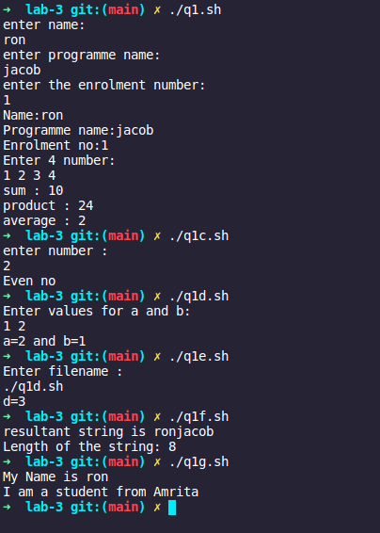

2. The length and breadth of a rectangle and radius of a circle are provided as user input. Write a shell script that will calculate the area and perimeter of the rectangle and the area and circumference of the circle.Hint: - Area of Rectangle = L*B Perimeter of Rectangle = 2(L+B) Area of Circle = π.r2 Circumference of circle = 2. π.r

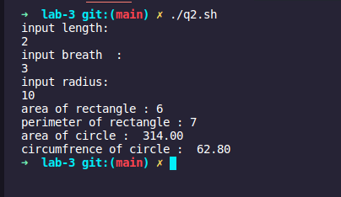

3. Write a menu driven shell program to read two numbers and print the results of all the arithmetic operations. ( + , - , * , / , % , ++ , -- )

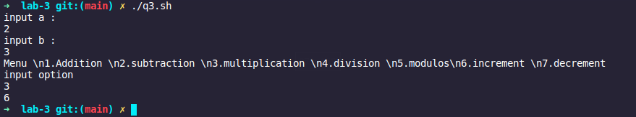

4. Write two separate shell scripts to find the factorial of a number using ***while*** statement and ***for*** statement.

Using **while** loop :

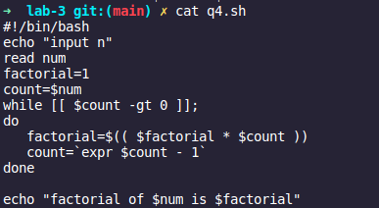

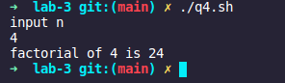

Using **For** loop:

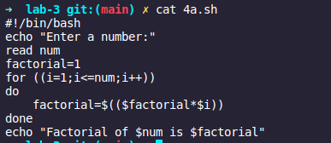

5. Given a file of numbers (one number per line), write a shell script that will find the lowest and highest number.

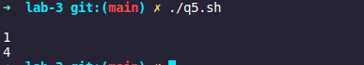

6. Write a shell program to read n numbers into an array and display the average of them.

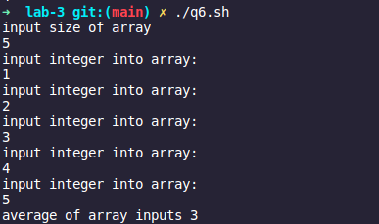

7. Write a shell program to print the following Patterns.

* * * * *

* * * *

* * *

* *

*

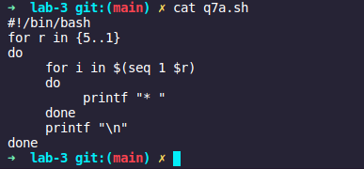



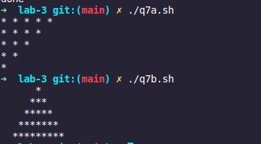

8.)Addition of two matrices

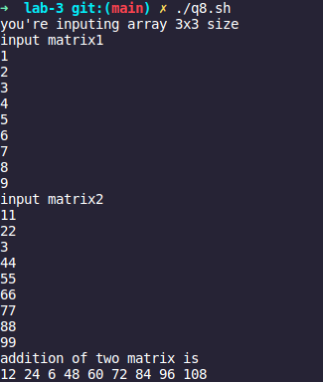

9.)transpose of a matrix

